**Git-hub Repo url :-** <https://github.com/sara-gnani/dev.git>

Dev is public repository, below image is from main branch

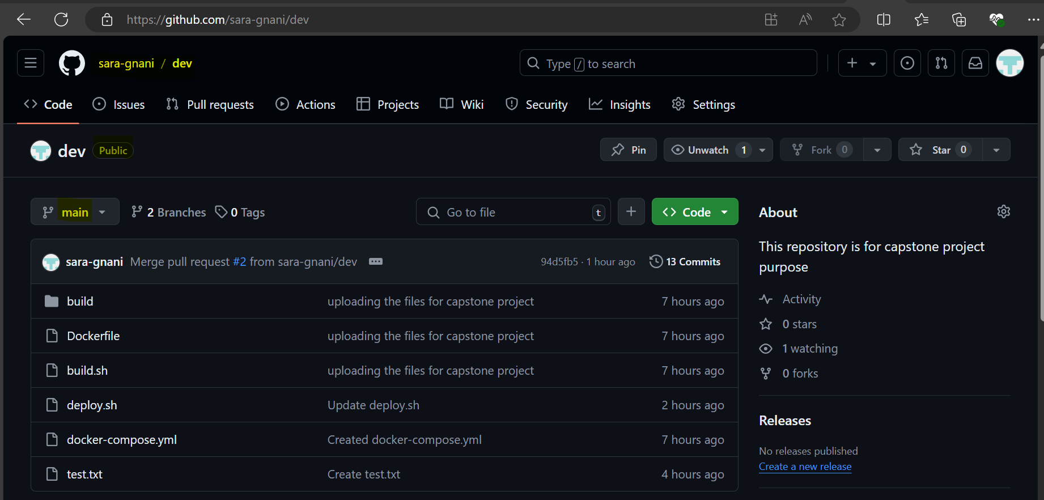

You can find the dev branch screen-print below

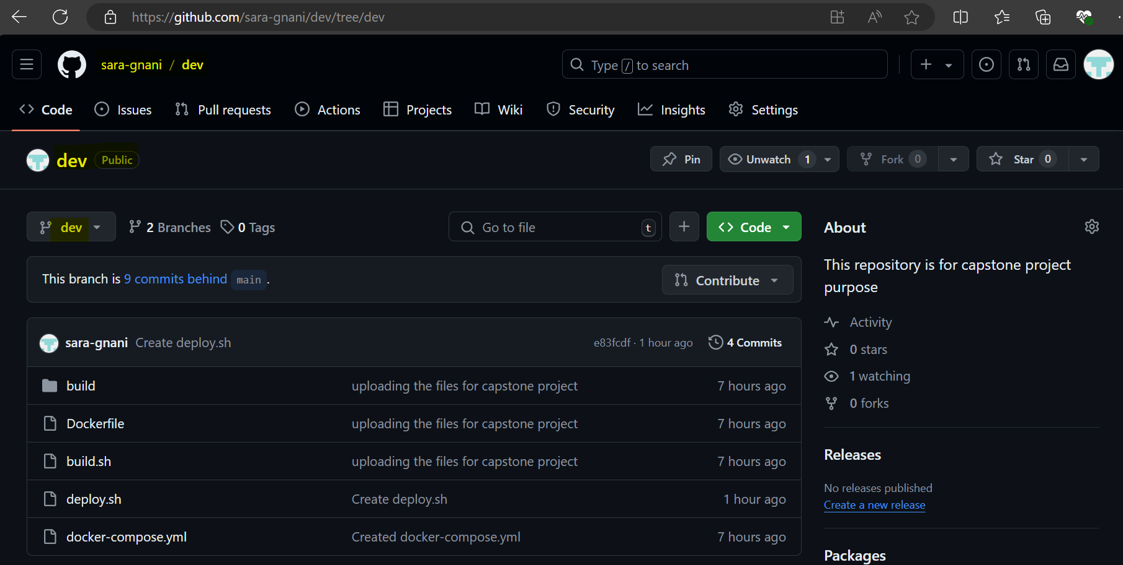

**Deployed site url :-** <http://13.235.8.176:5000/>

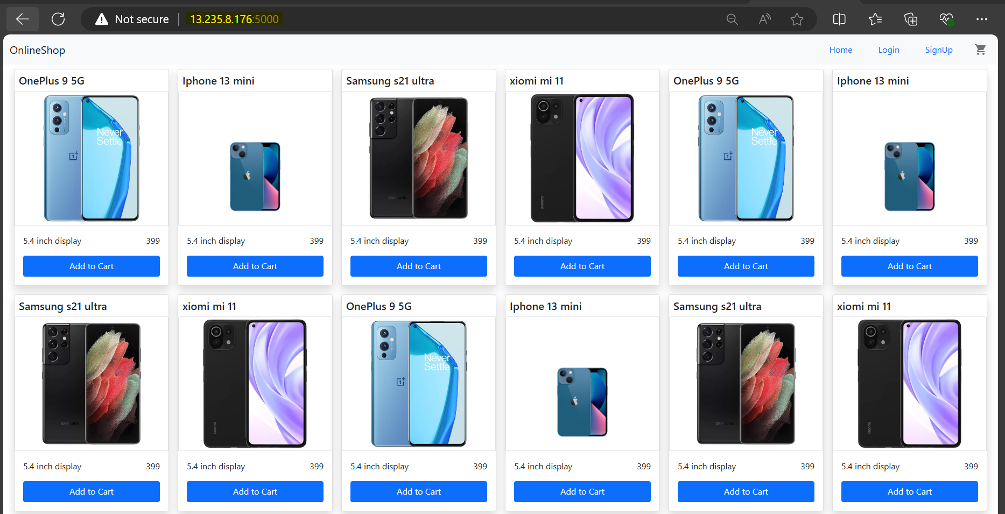

Below pasting the Instance details for validation

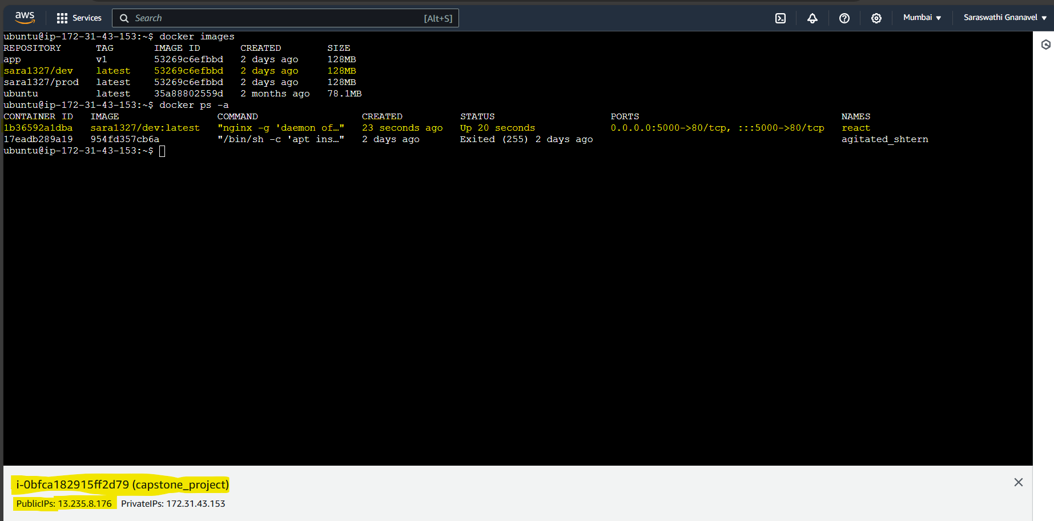

**Jenkins:-**

**Login page**

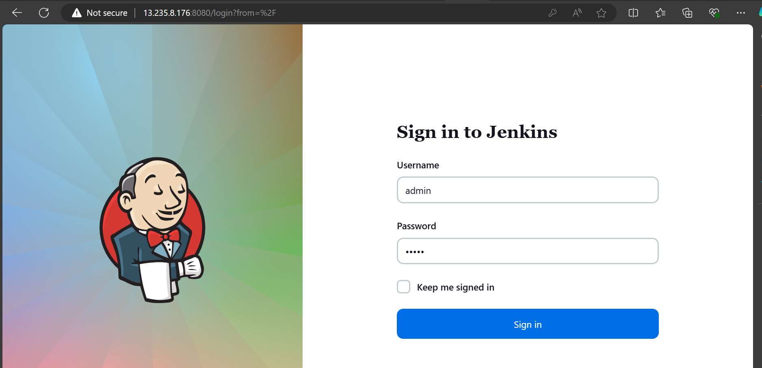

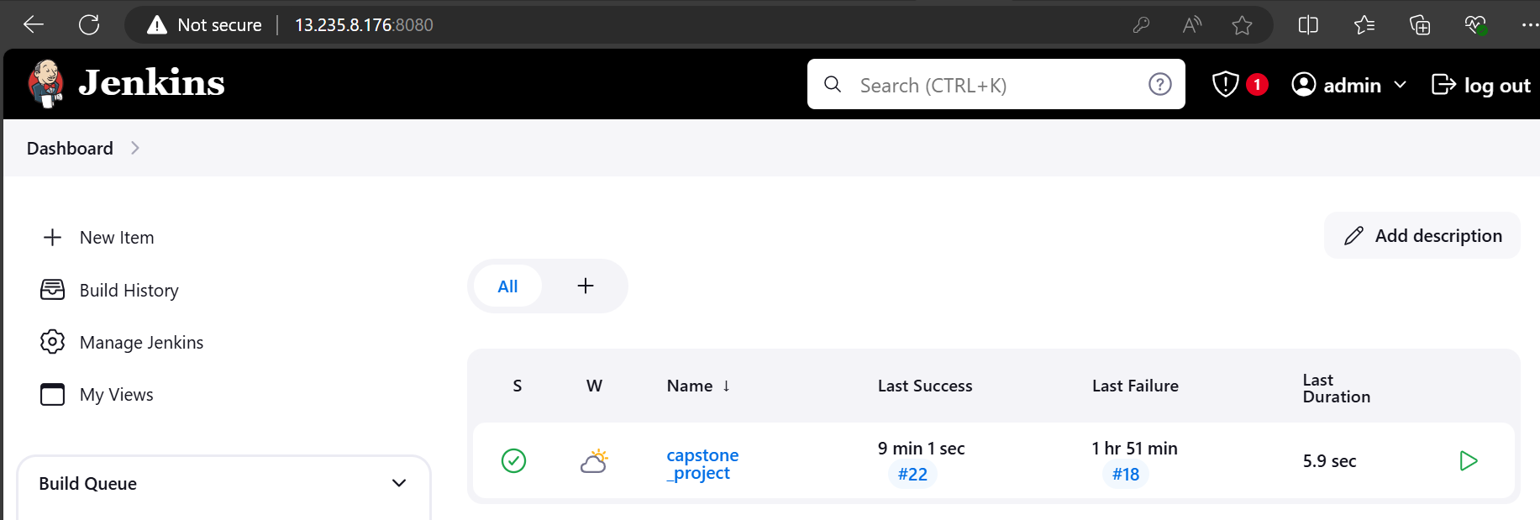

**Configuration settings**

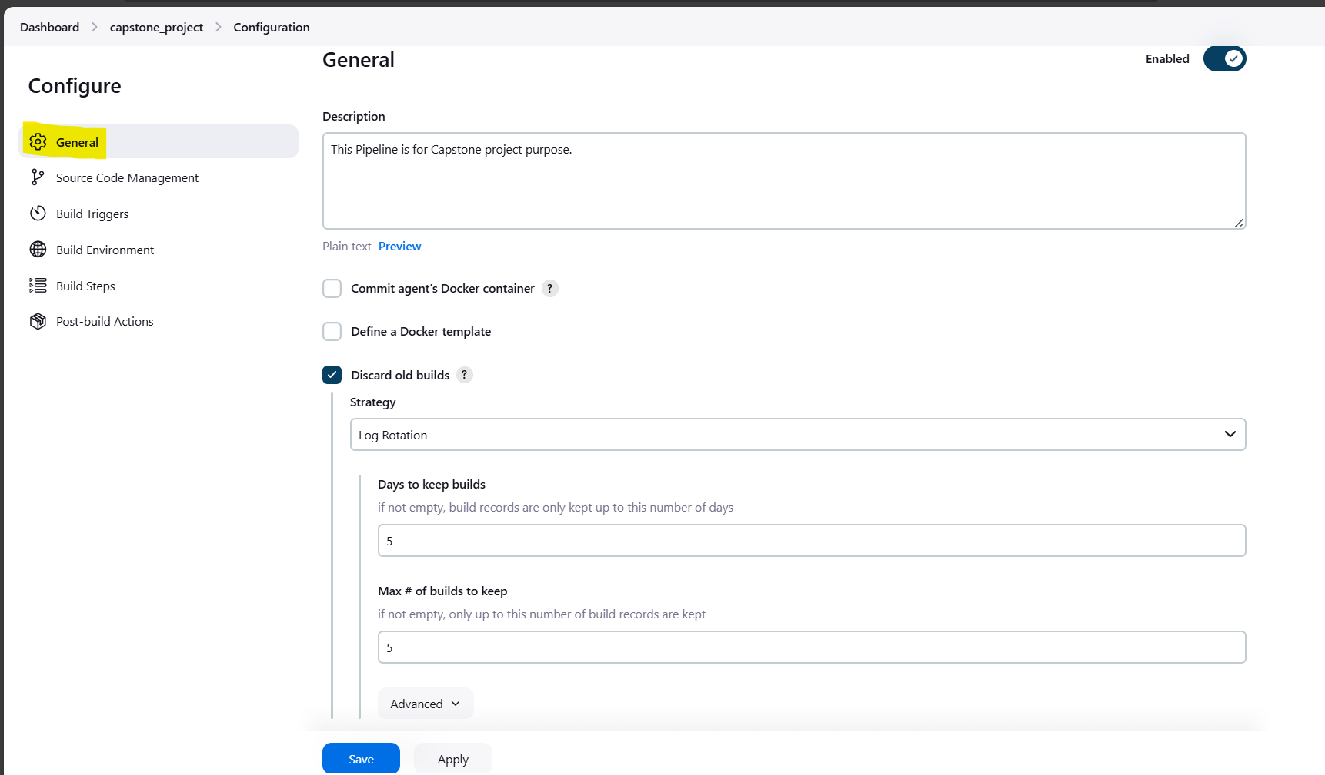

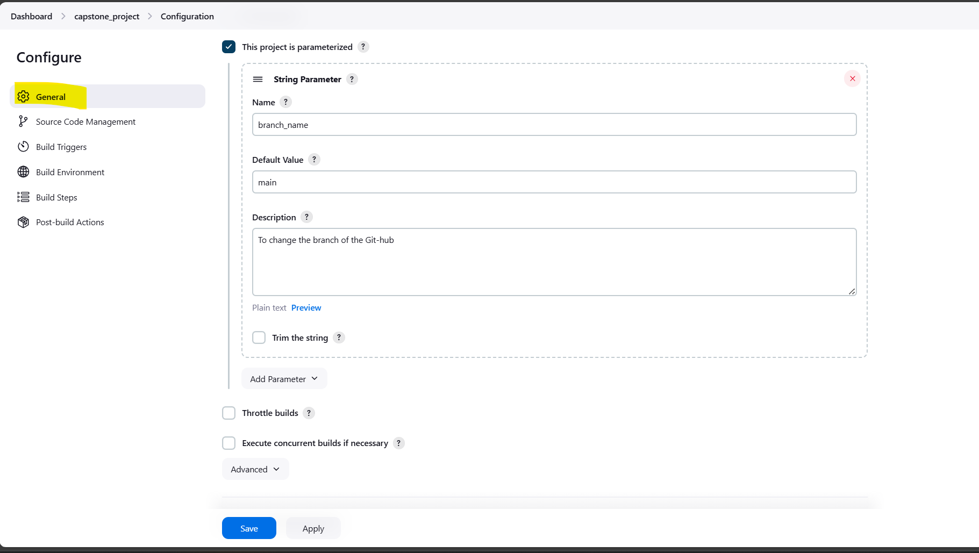

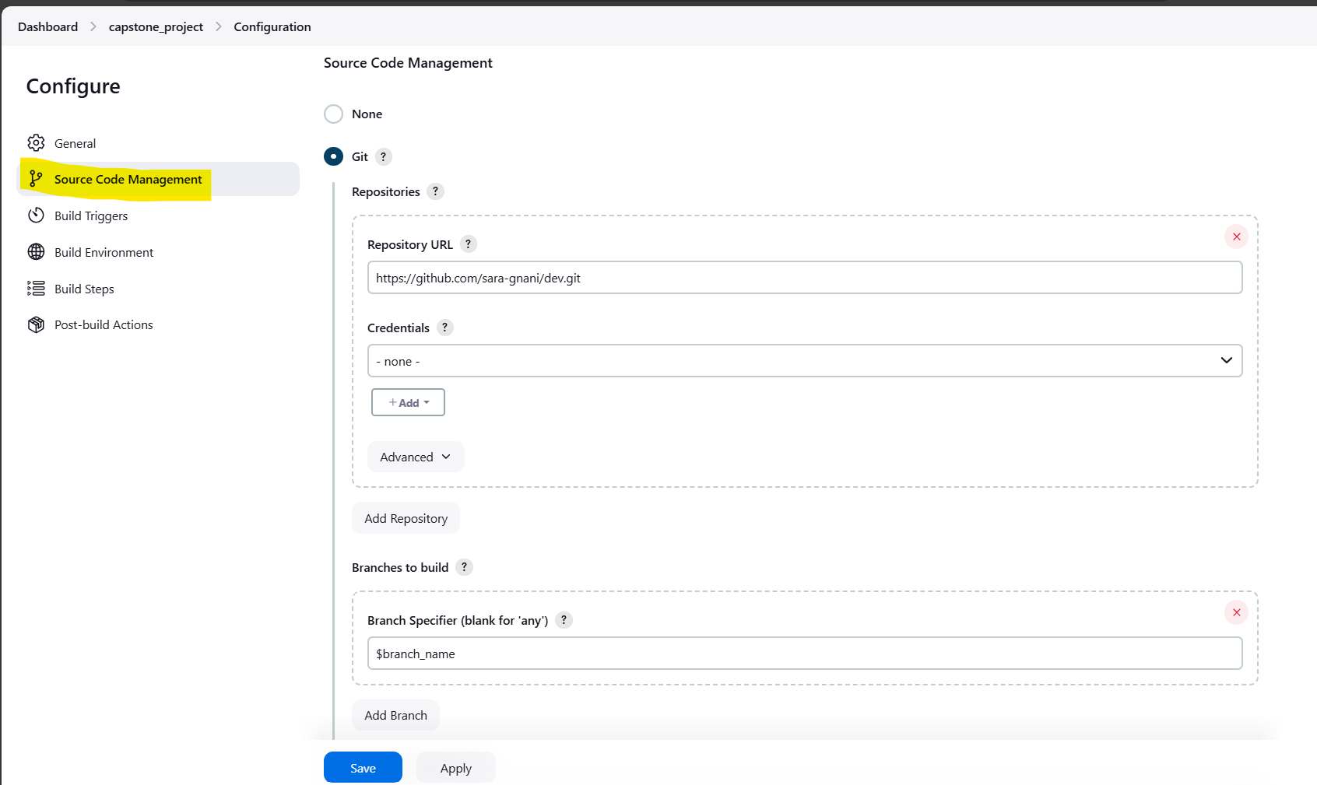

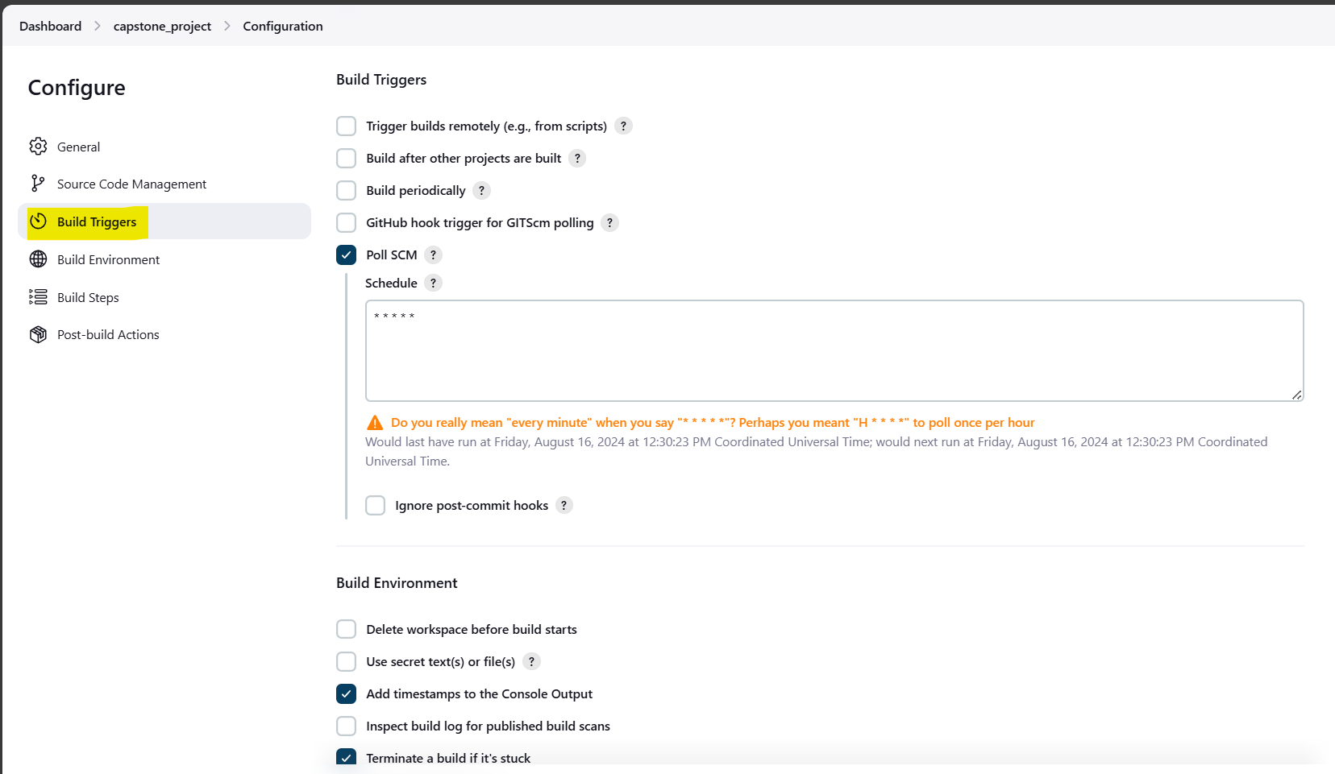

**Execute step**

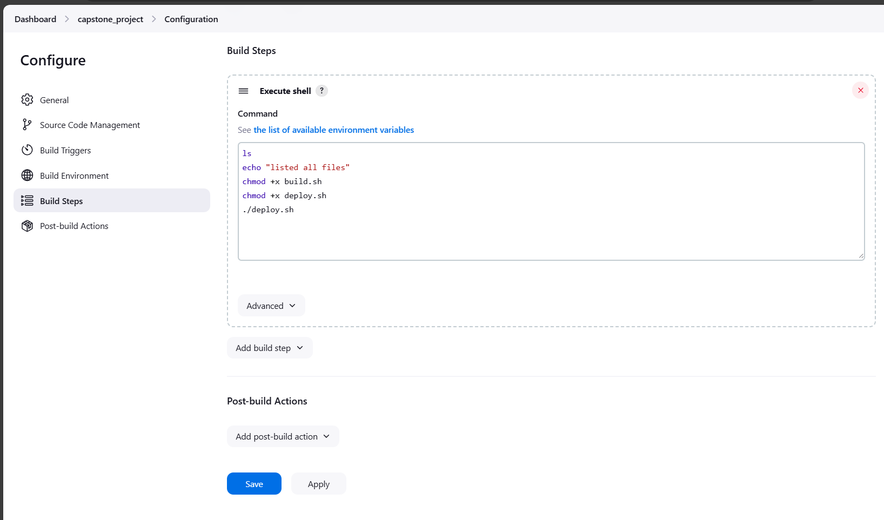

**Below you can find the console output of build which is performed using Dev repository(Git-hub) in Dev branch**



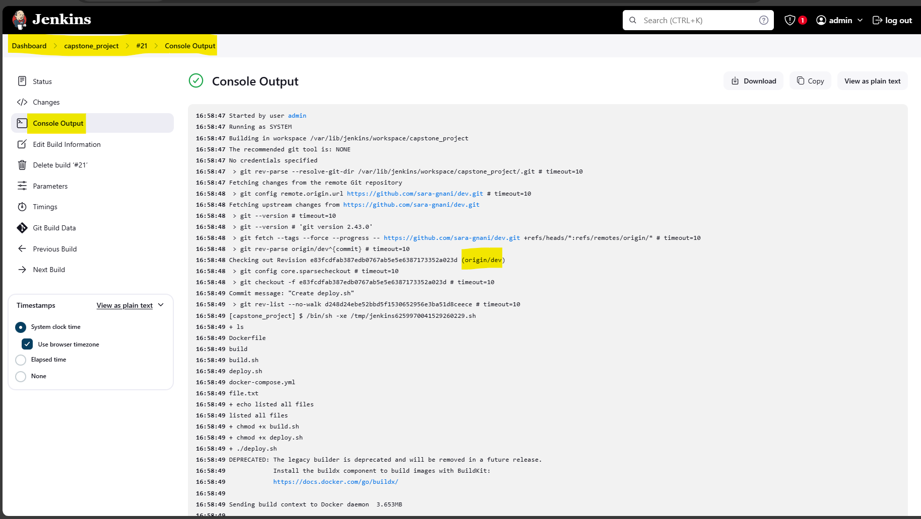

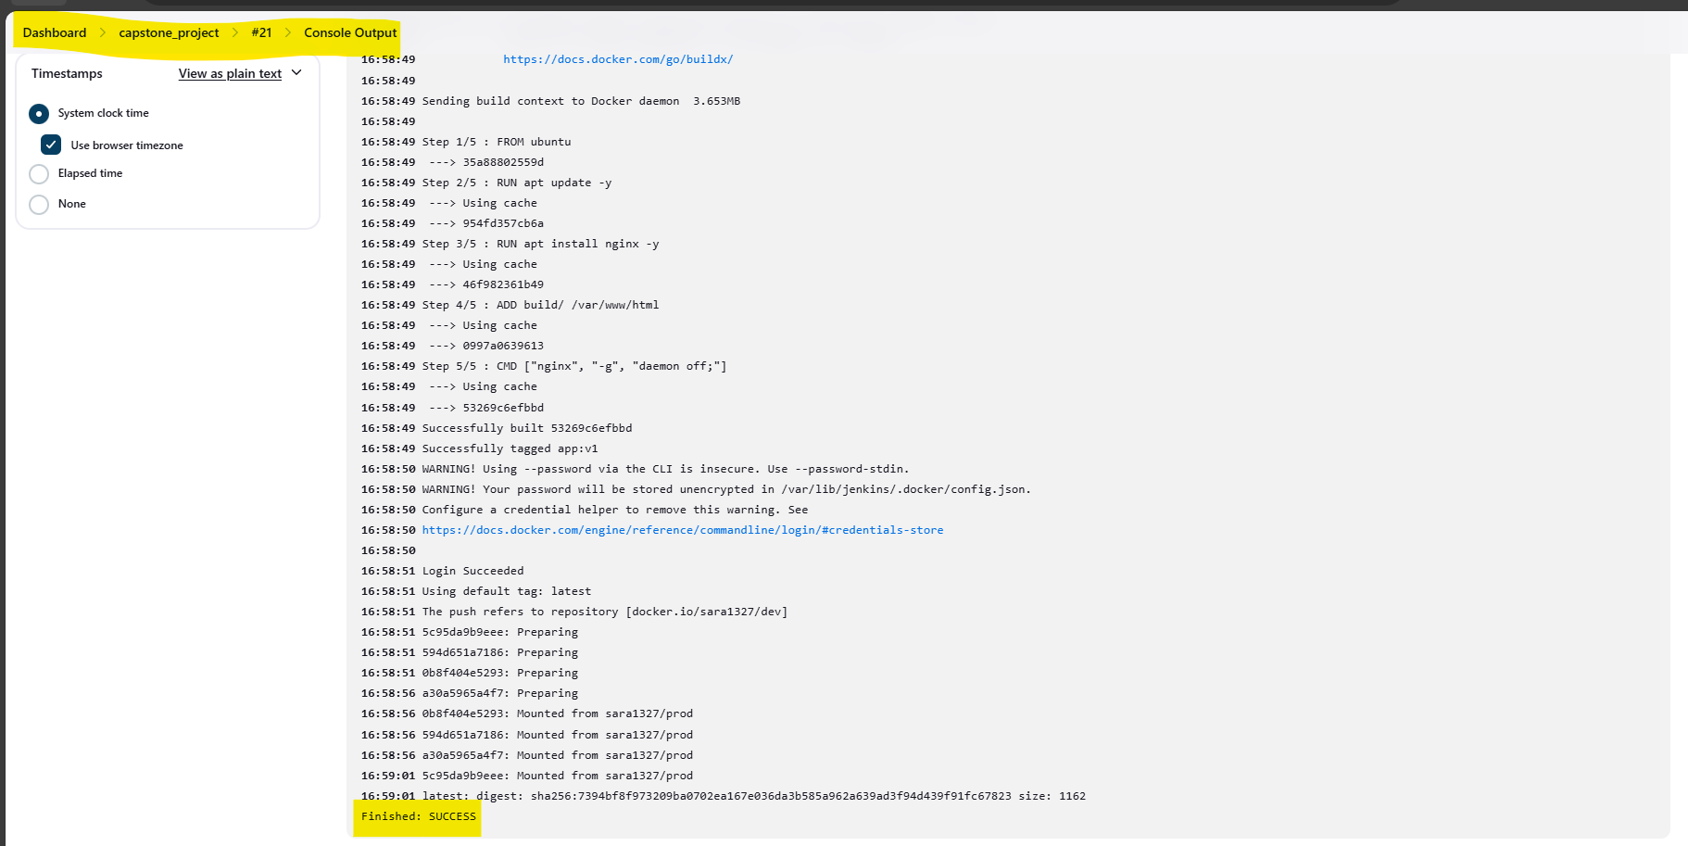

**Below you can find the console output of build which is performed using Dev repository(Git-hub) in Main branch**



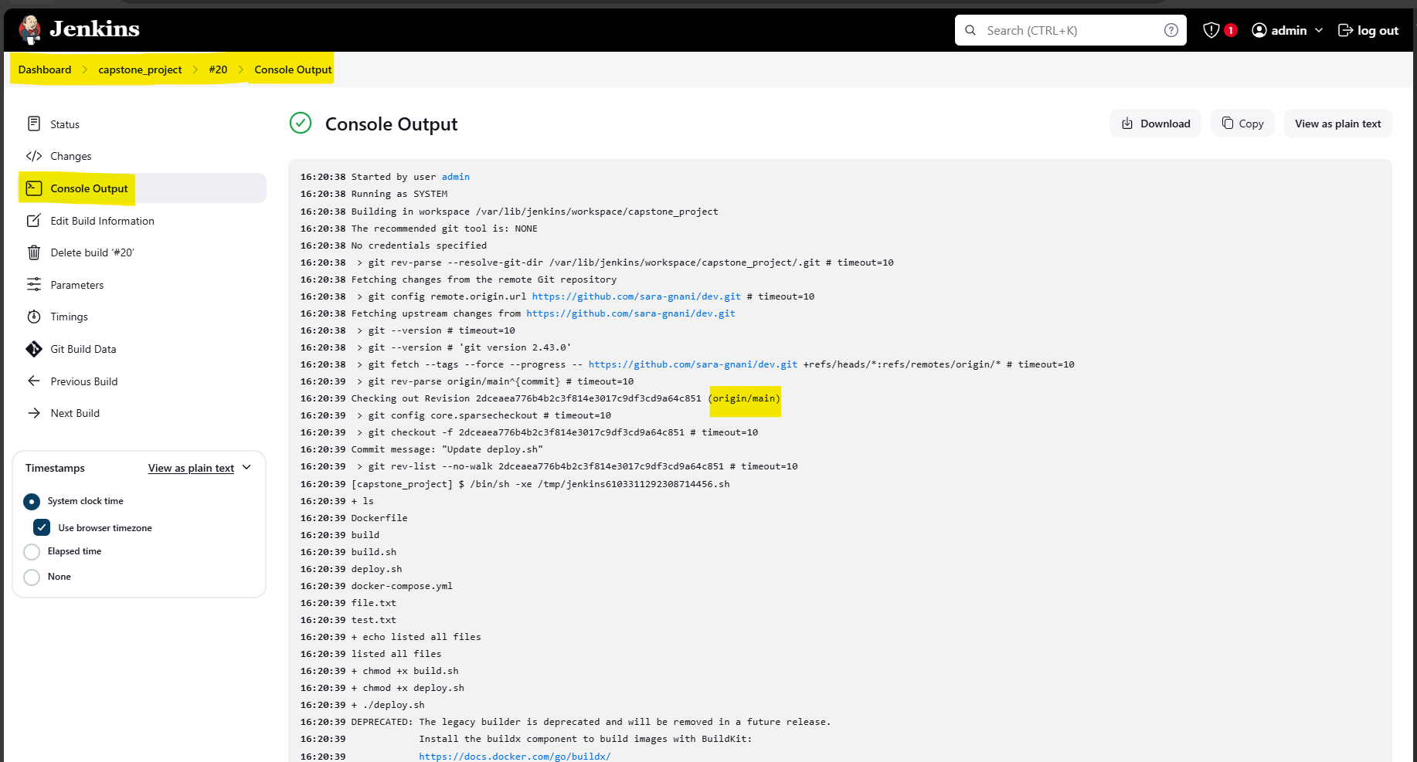

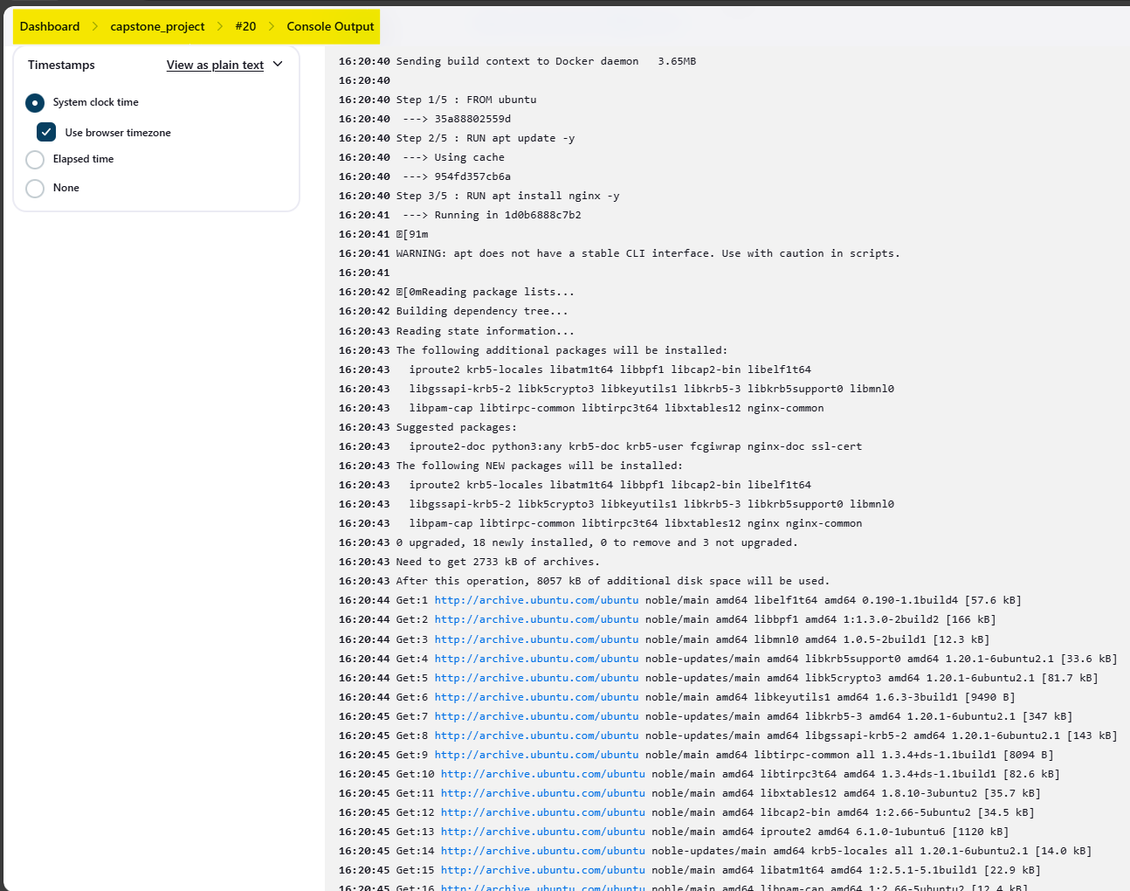

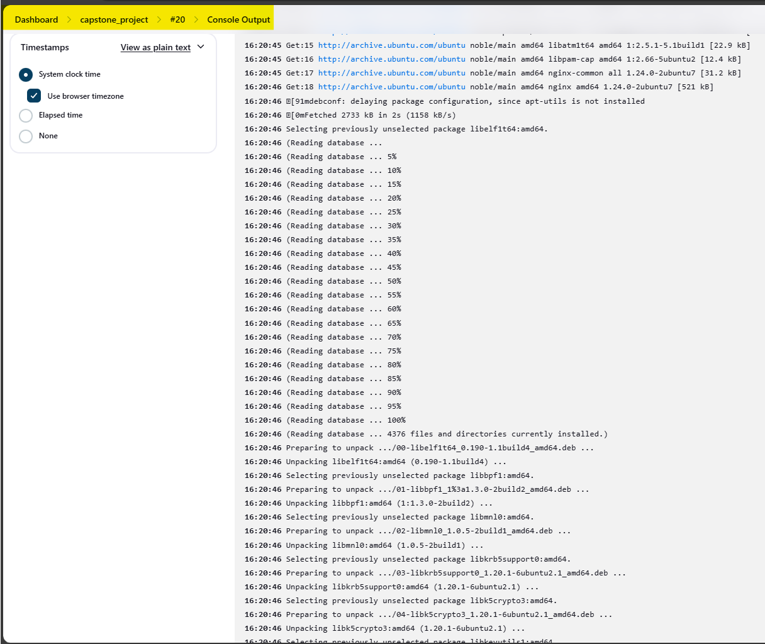

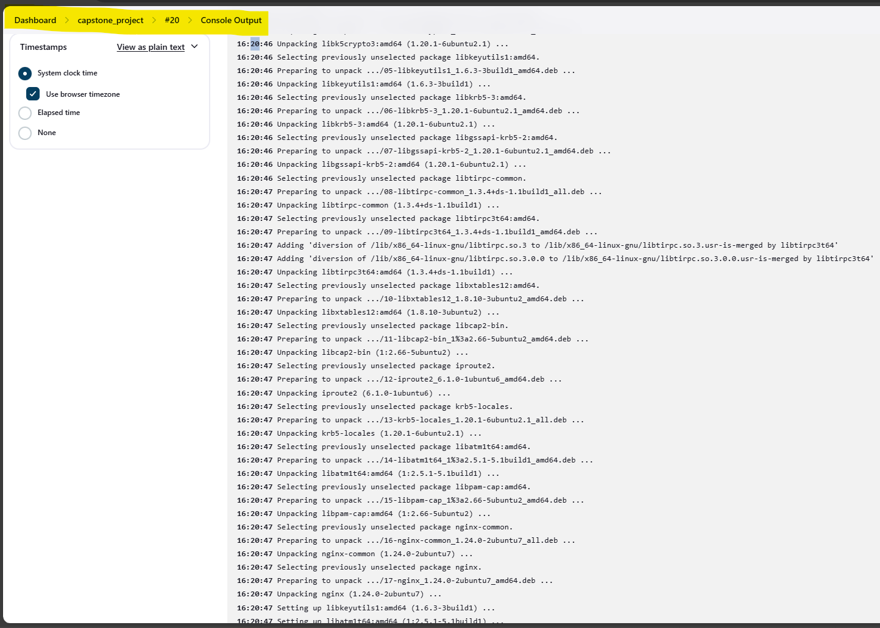

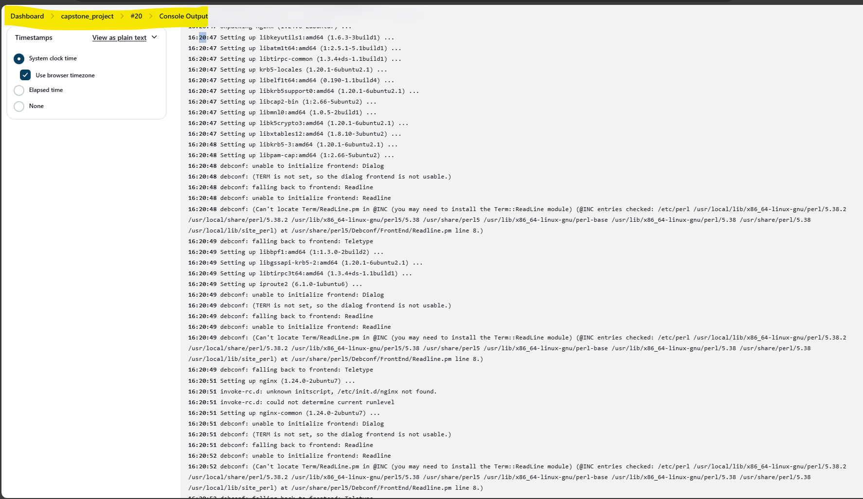

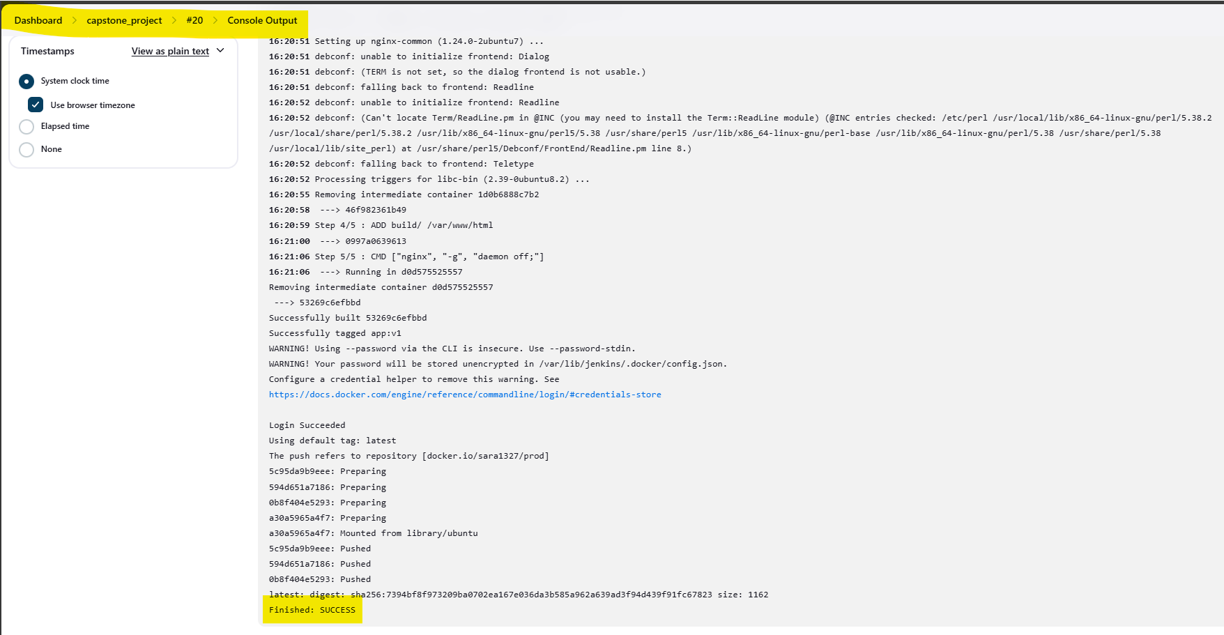

**AWS**

Below instance is used to access Jenkins

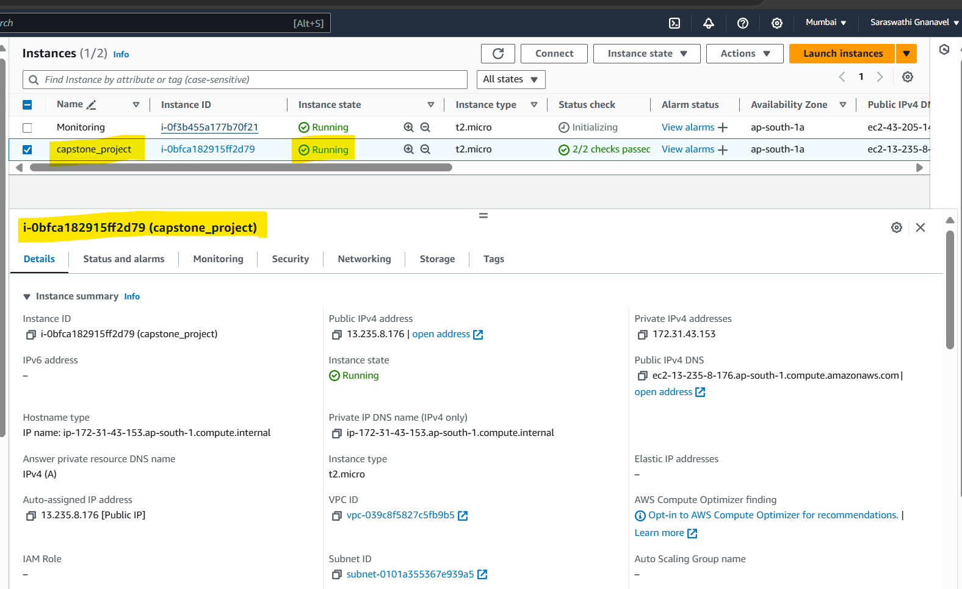

**Security group**

Modified the security group by adding the inbound rule.

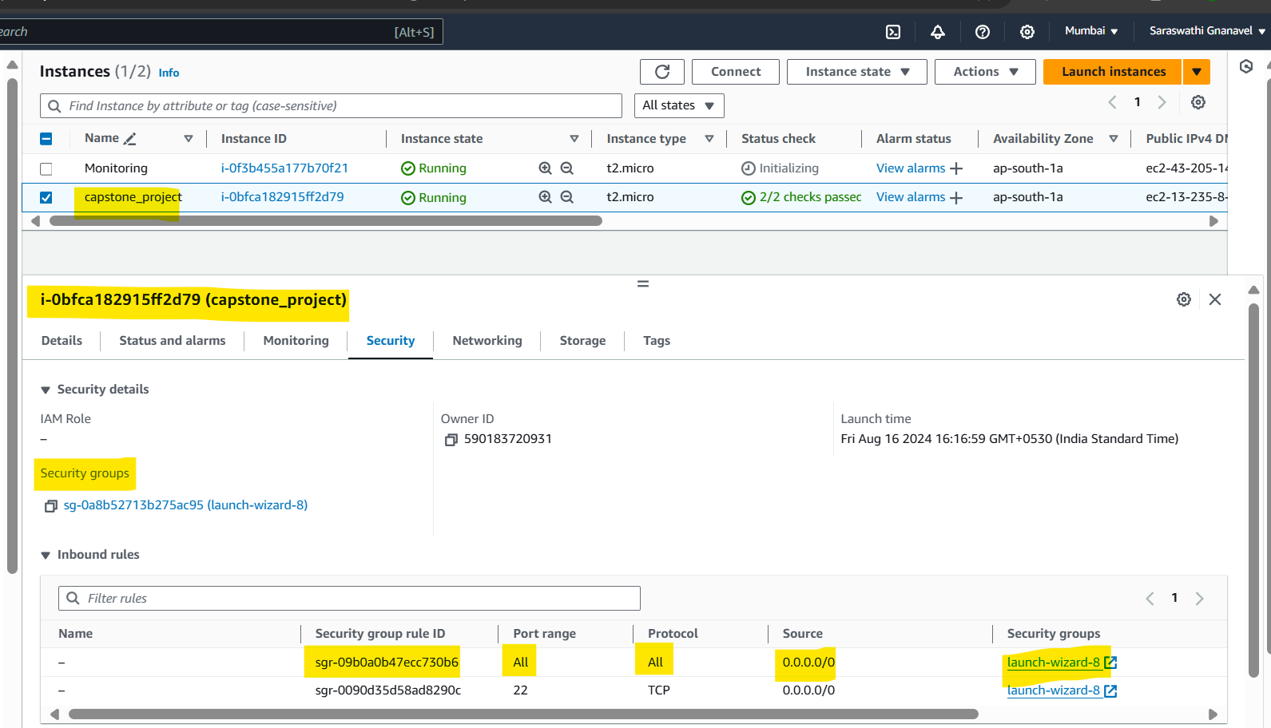

Below instance is used to access the Monitoring tool(Prometheus & Grafana)

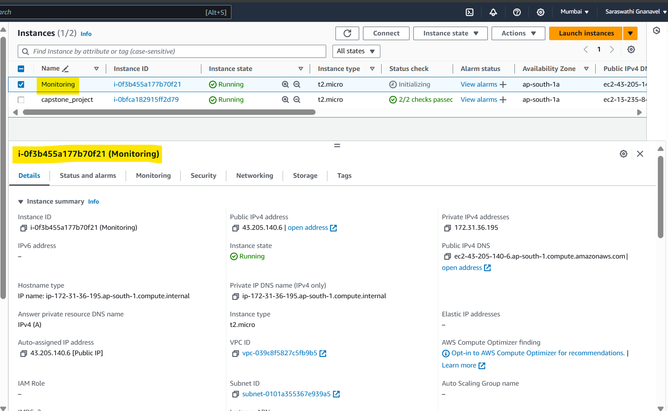

**Security group has been updated by adding inbound rule.**

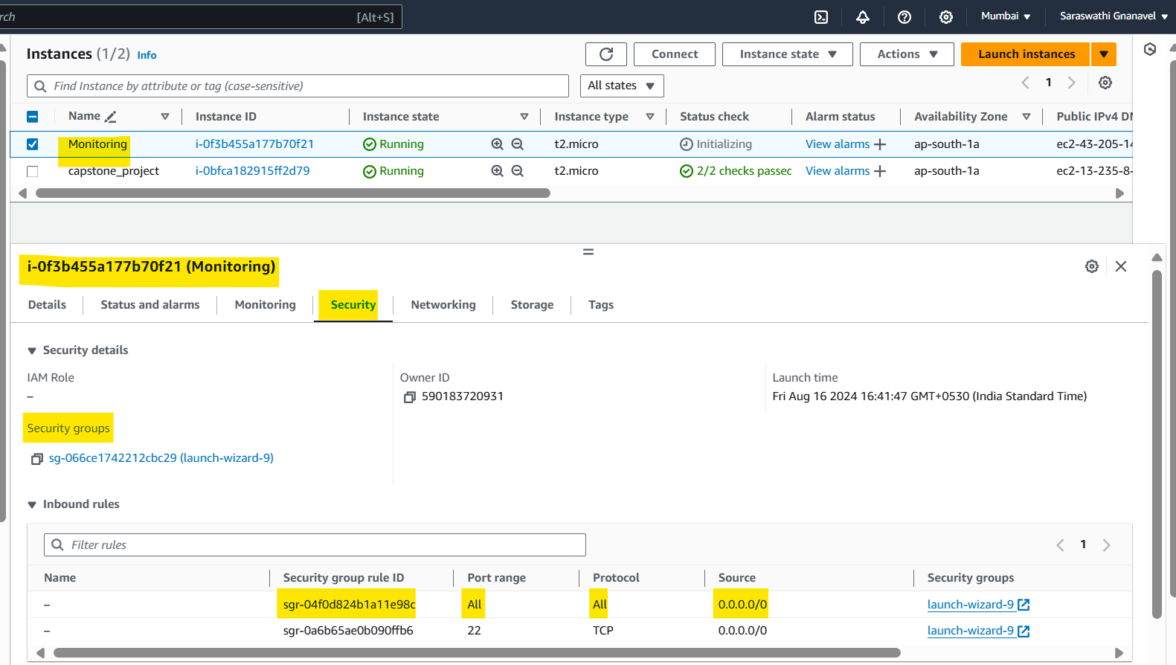

**Docker hub**

**Repositories (prod🡪Private repo and dev🡪Public repo)**

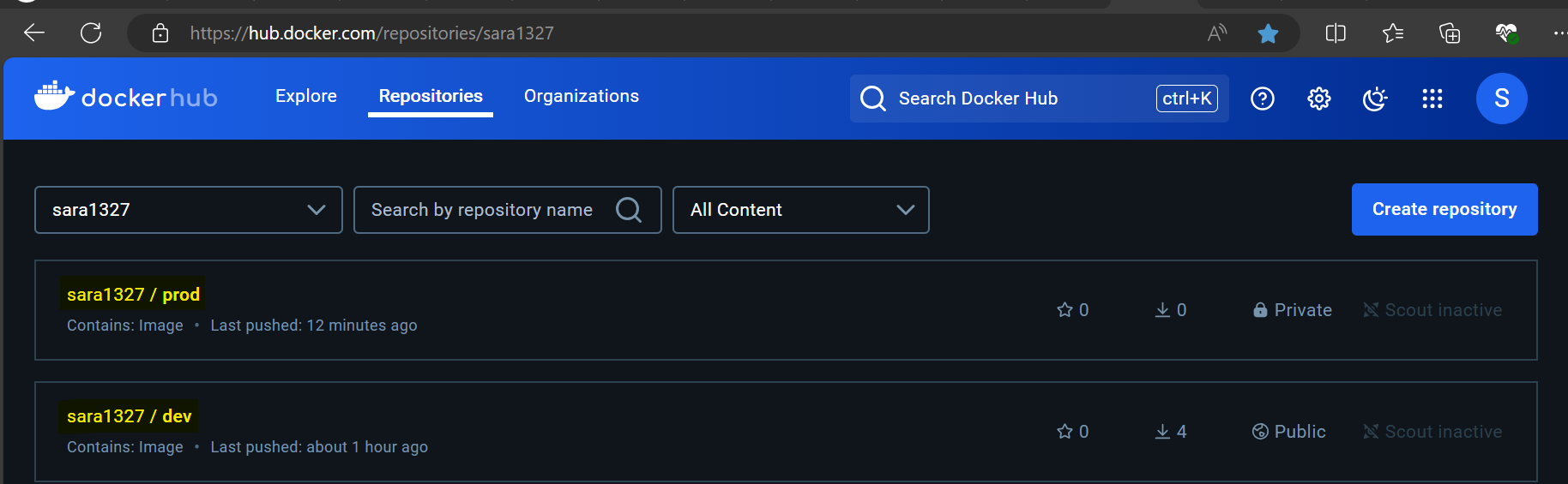

**Image and tag details of sara1327/dev**

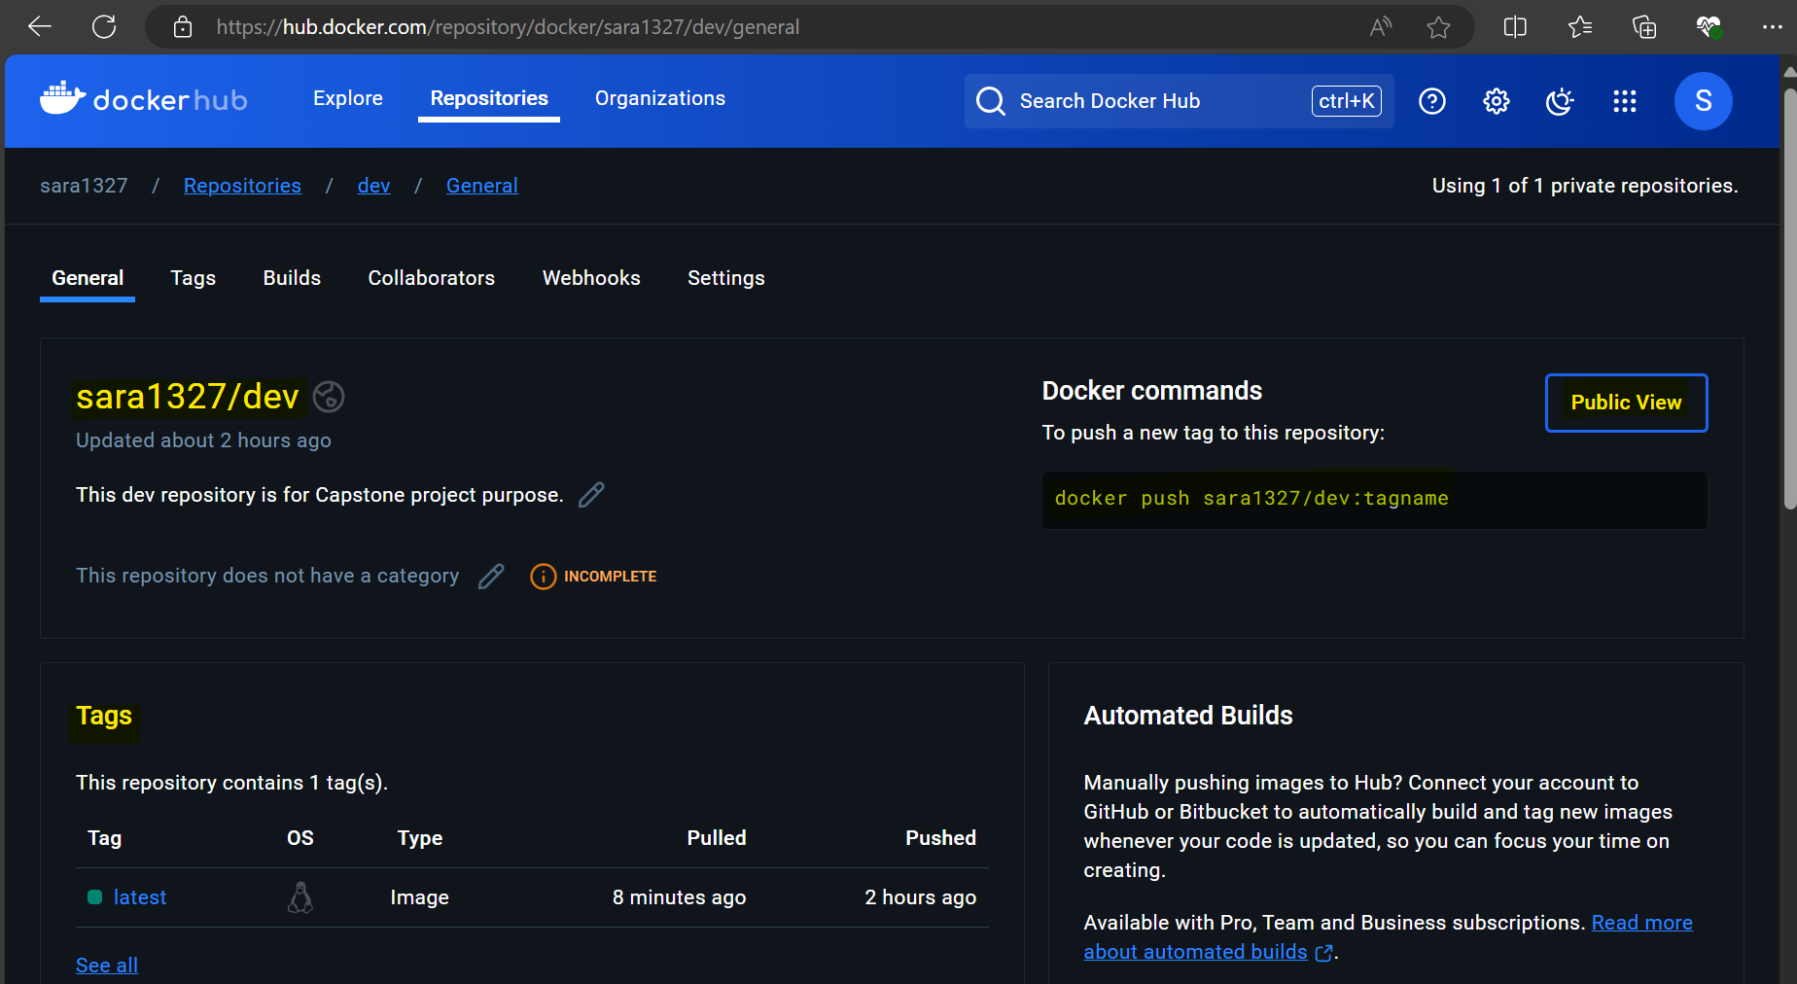

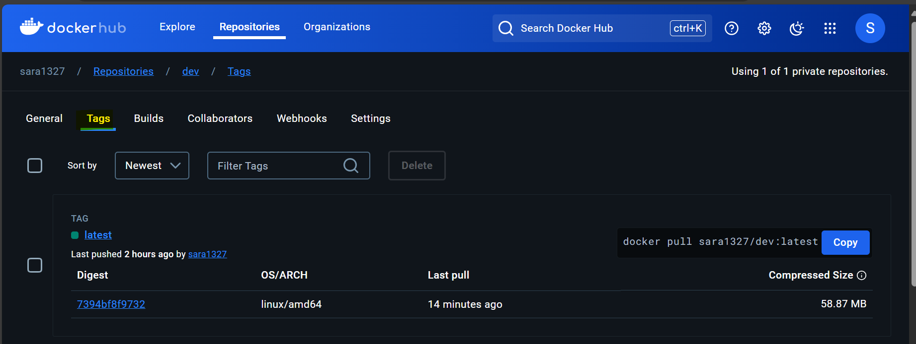

**Image and tag details of sara1327/prod**

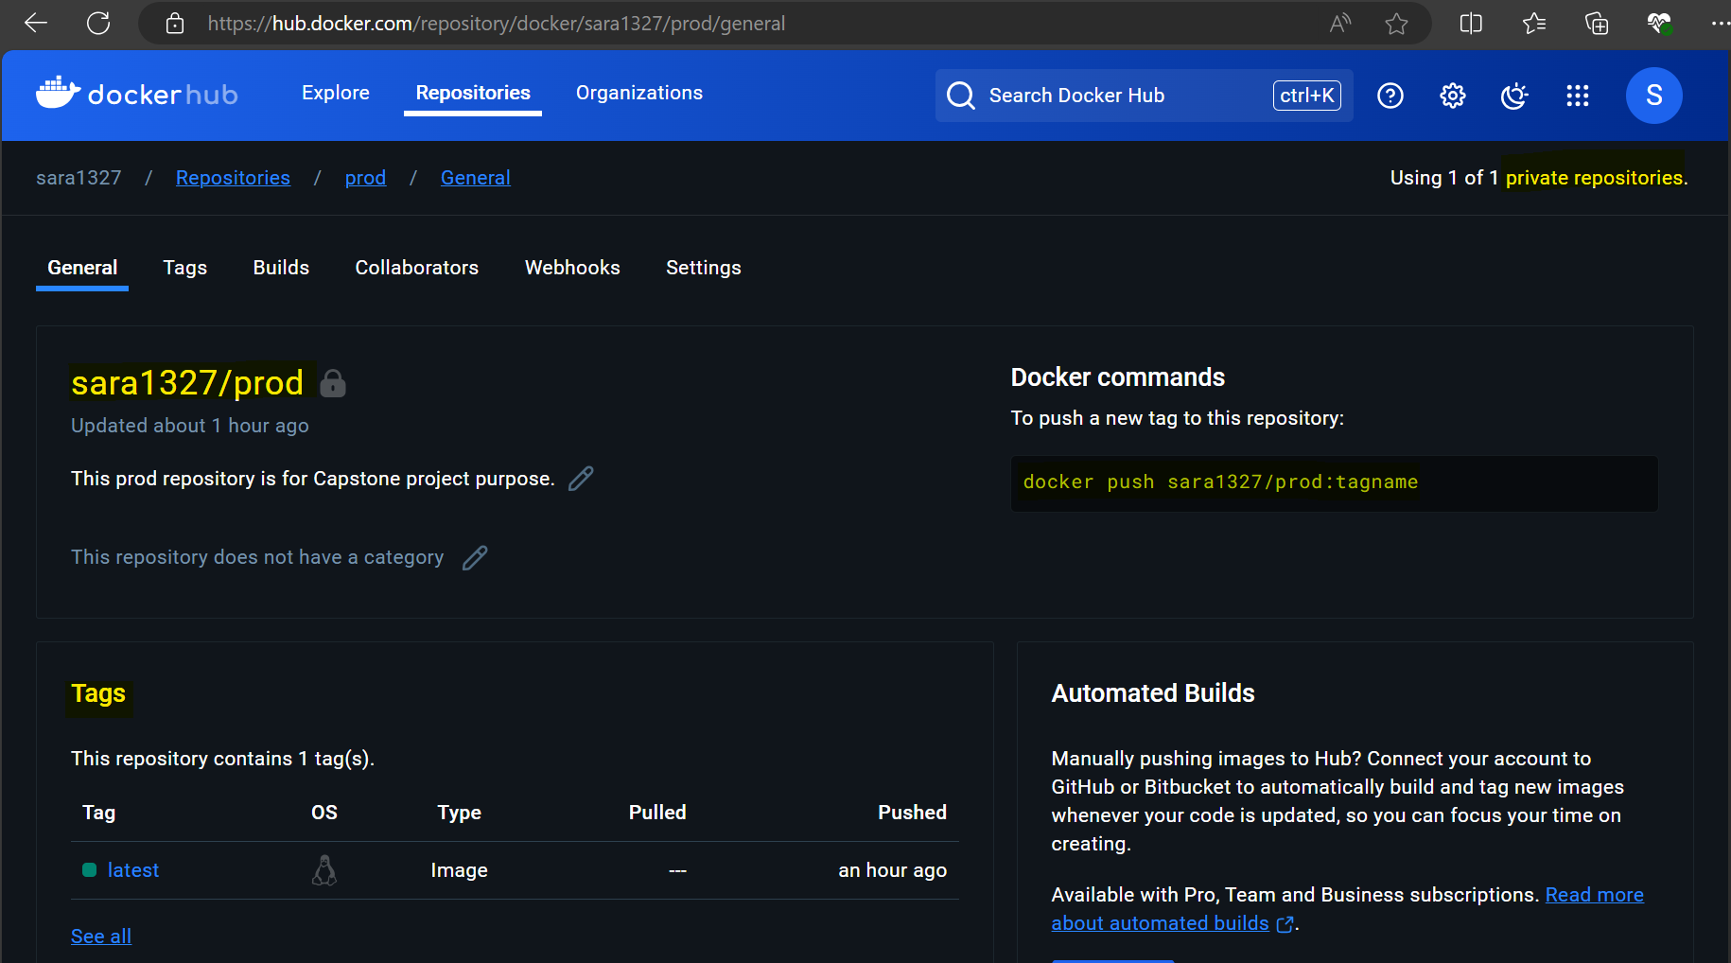

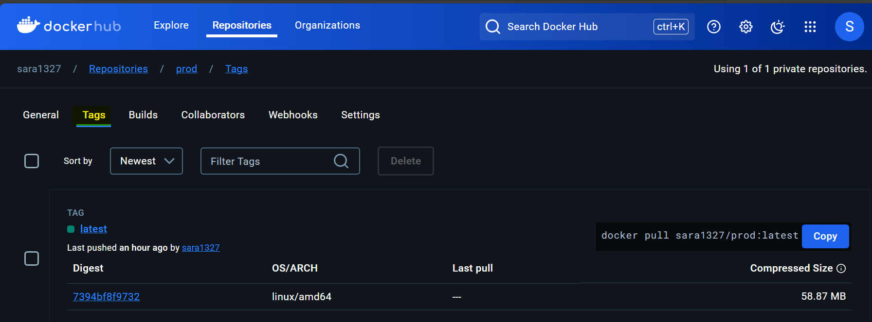

**Deployed site page**

Site url :- <http://13.235.8.176:5000/>



Below pasting the Instance details for validation



**Monitoring health check status**

Installed Prometheus, Grafana in Monitoring Instance(Public IPs: 43.205.140.6)

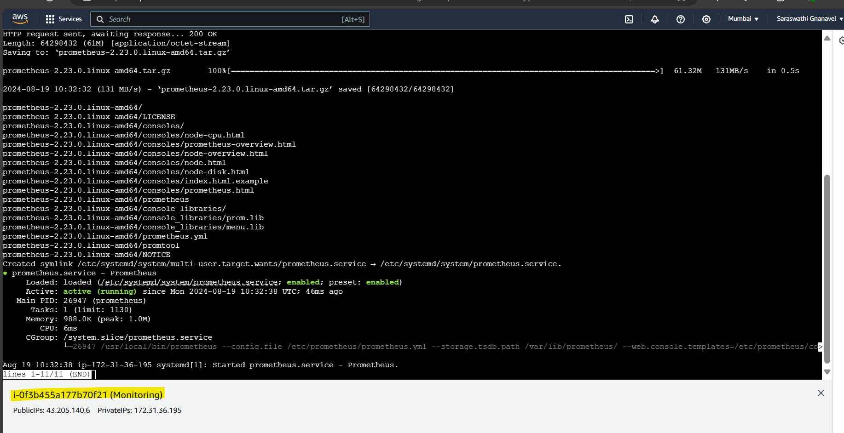

Prometheus is running

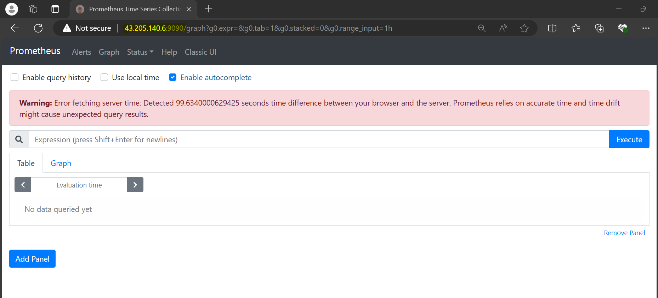

Installed Grafana in same instance

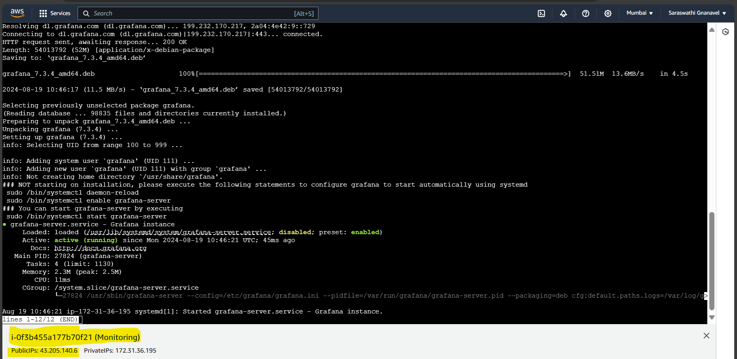

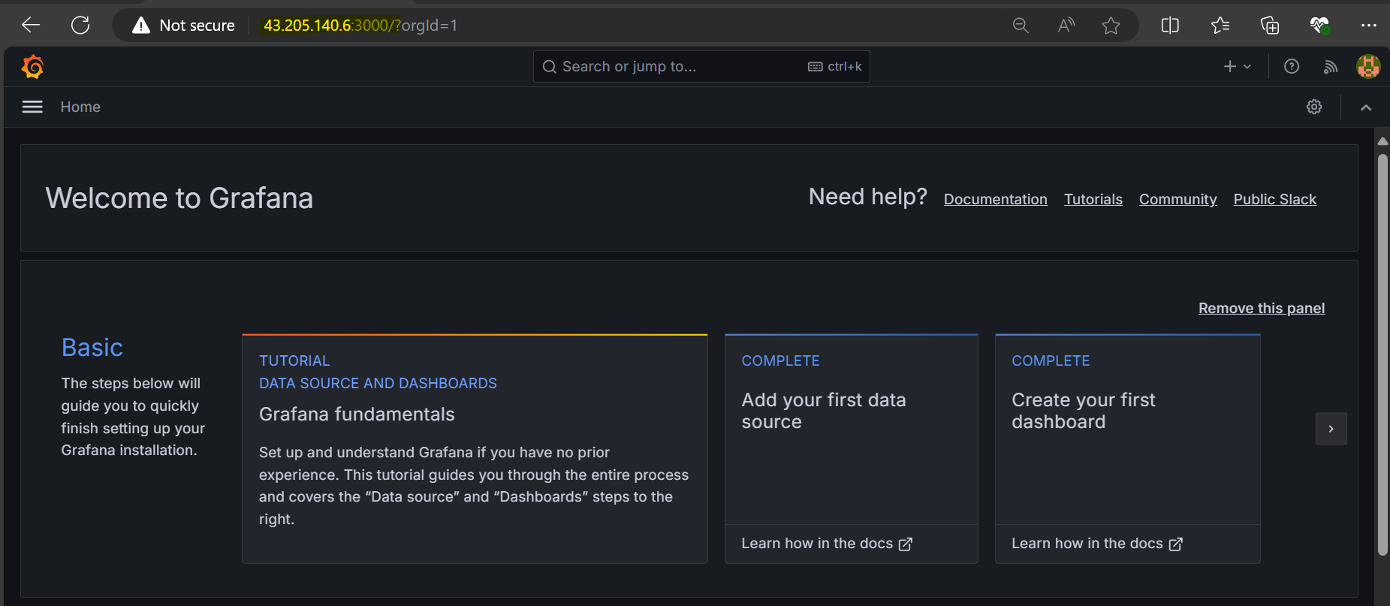

Added the Data source as Prometheus

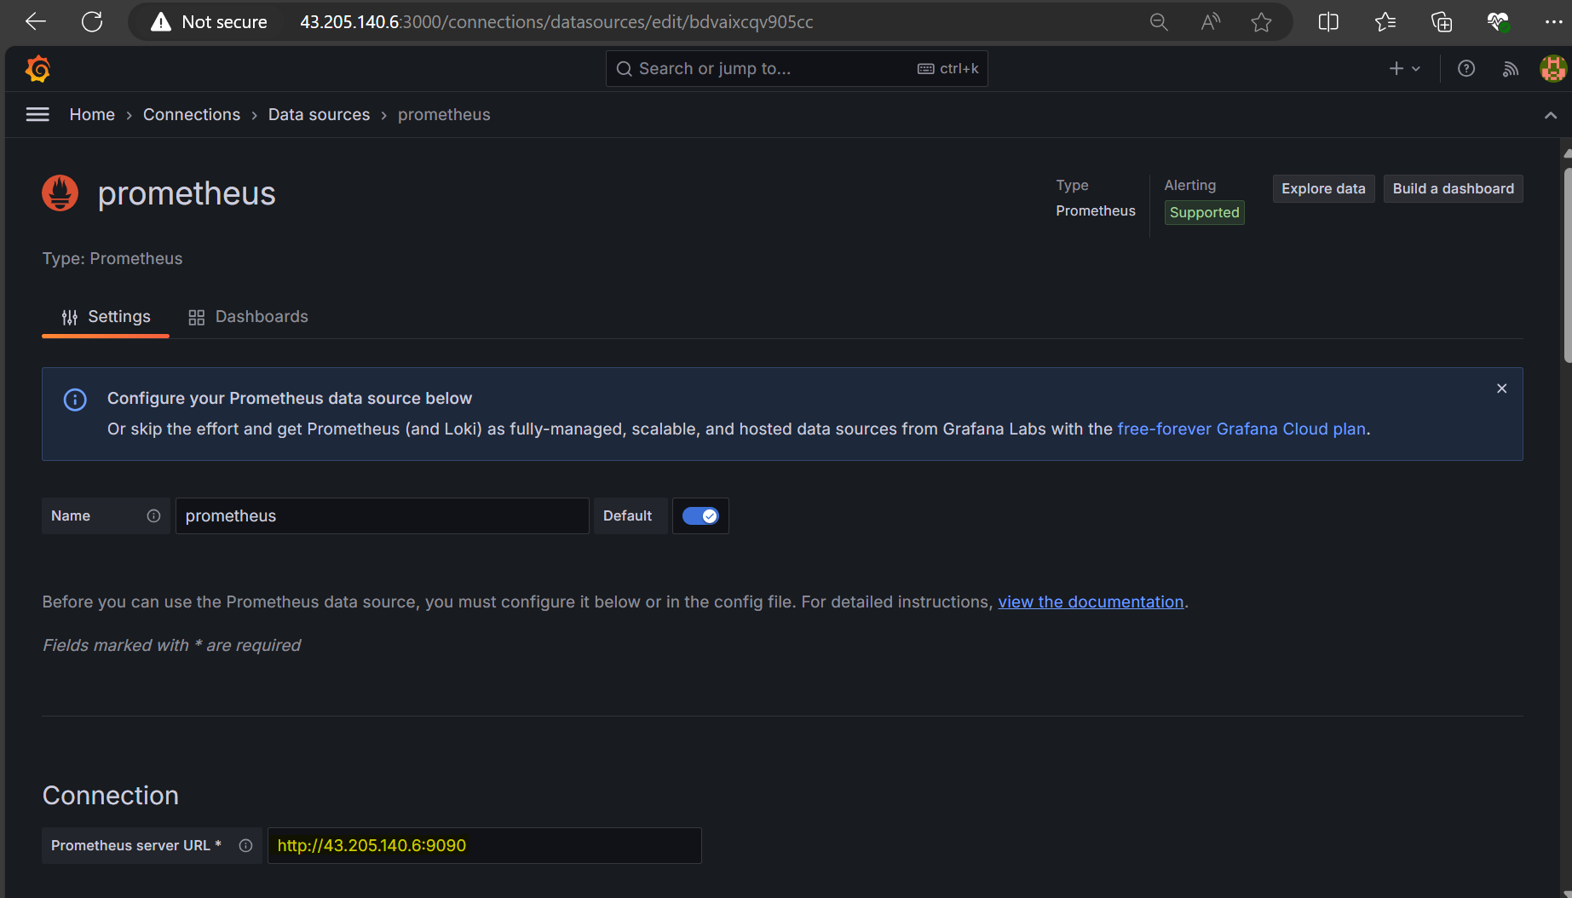

Imported Grafana dashboard from Grafana labs

Referred the following url :- <https://grafana.com/grafana/dashboards/1860-node-exporter-full/>

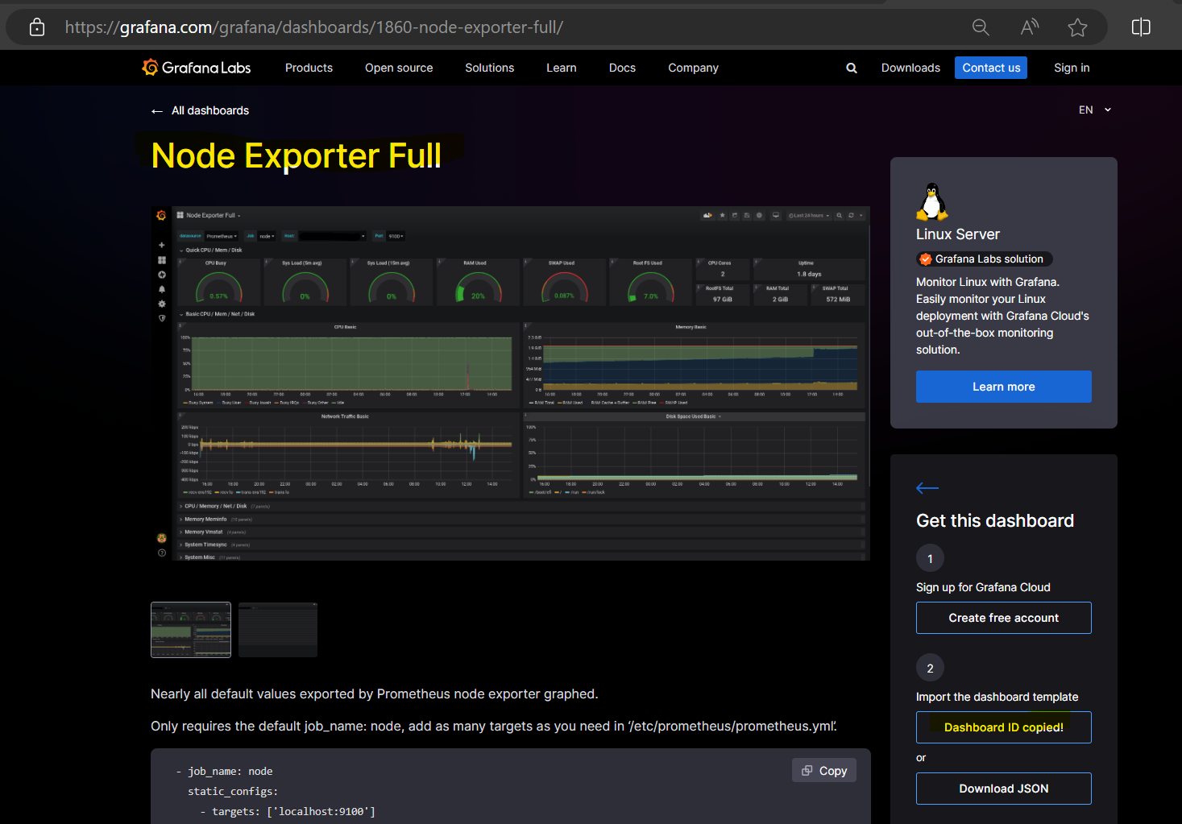

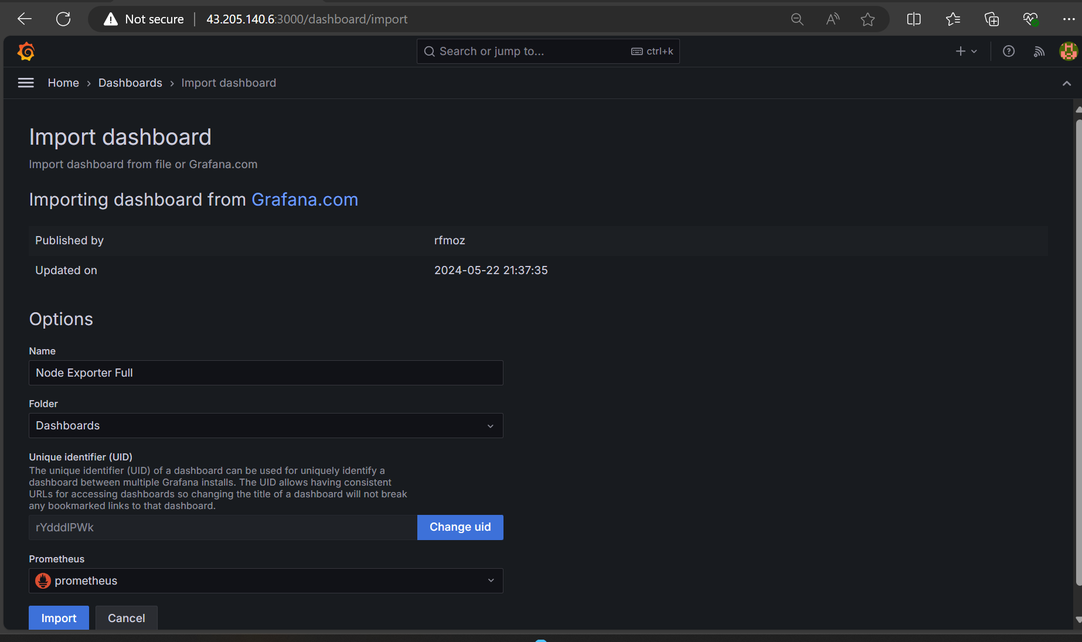

Installed node-exporter in capstone_project(PublicIPs: 13.235.8.176)

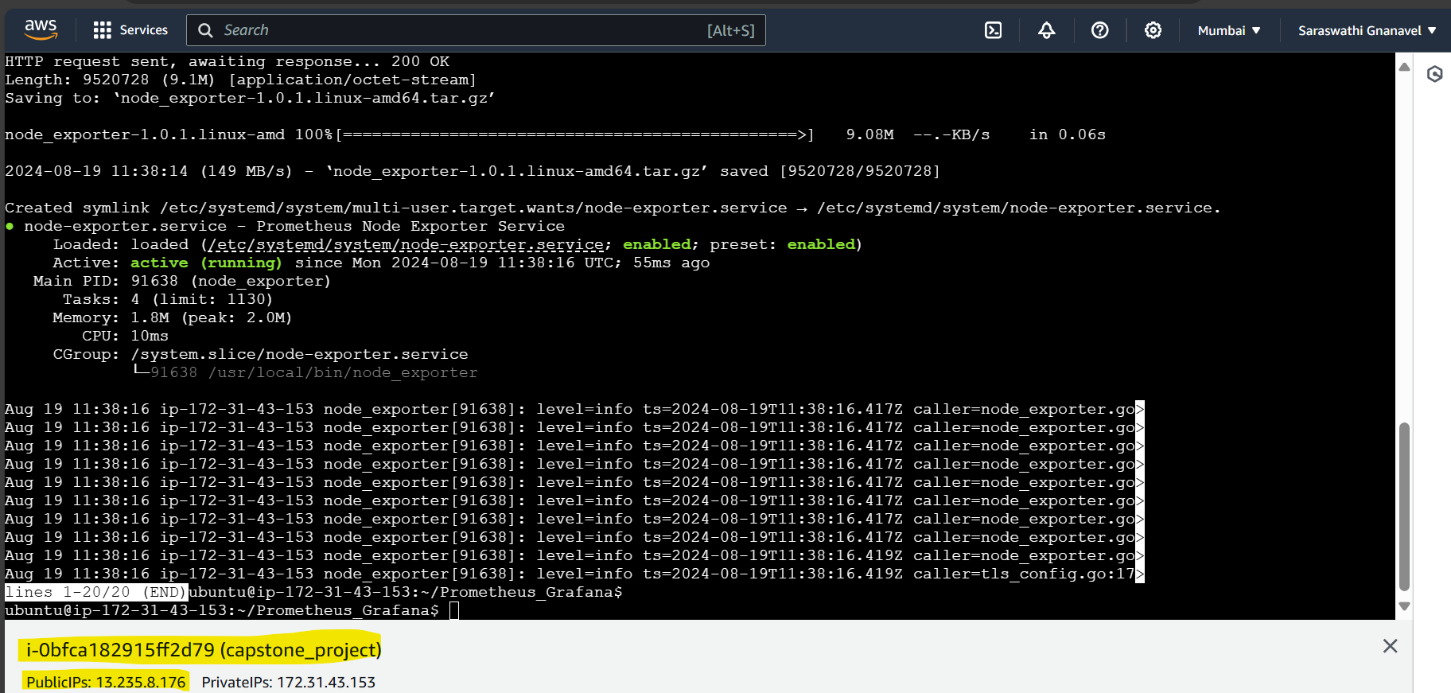

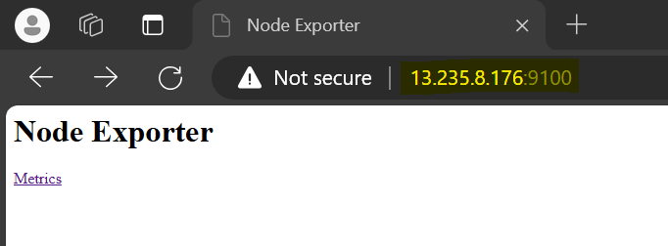

Now configured node-exporter with prometheus via prometheus.yml file at Monitoring instance(PublicIPs: 43.205.140.6)

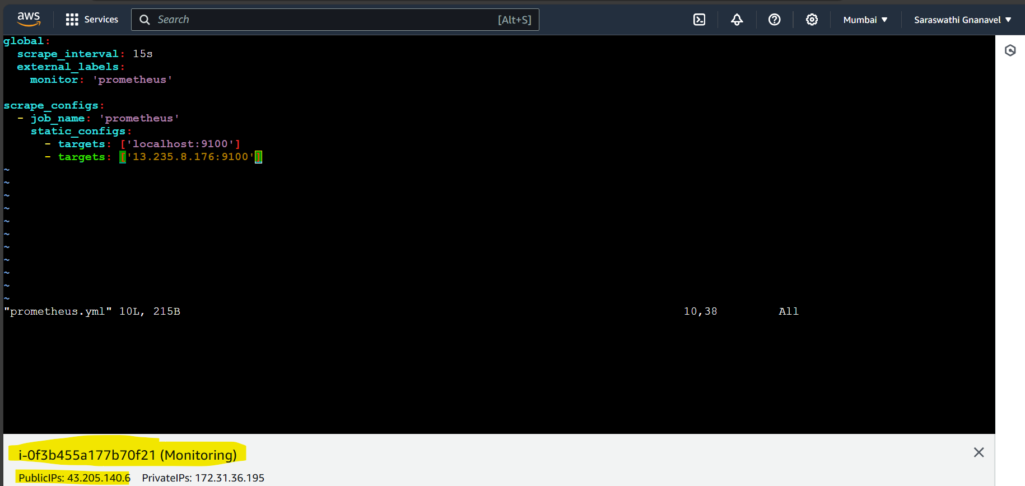

Restarted prometheus after updating the configuration file

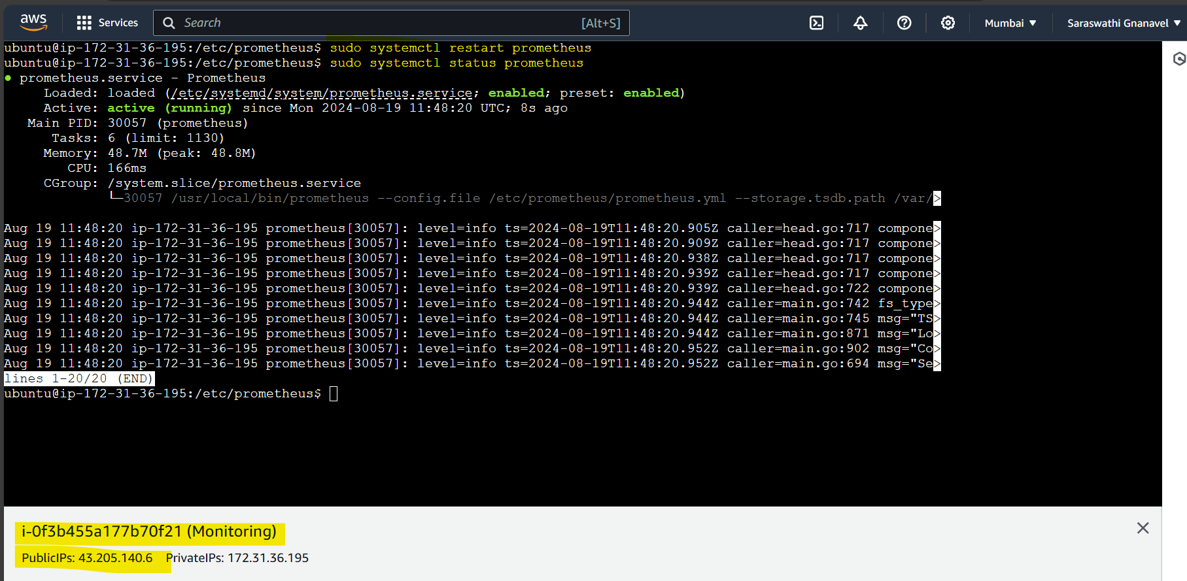

Now, you can able to find our target in the below screen-print in the highlighted format

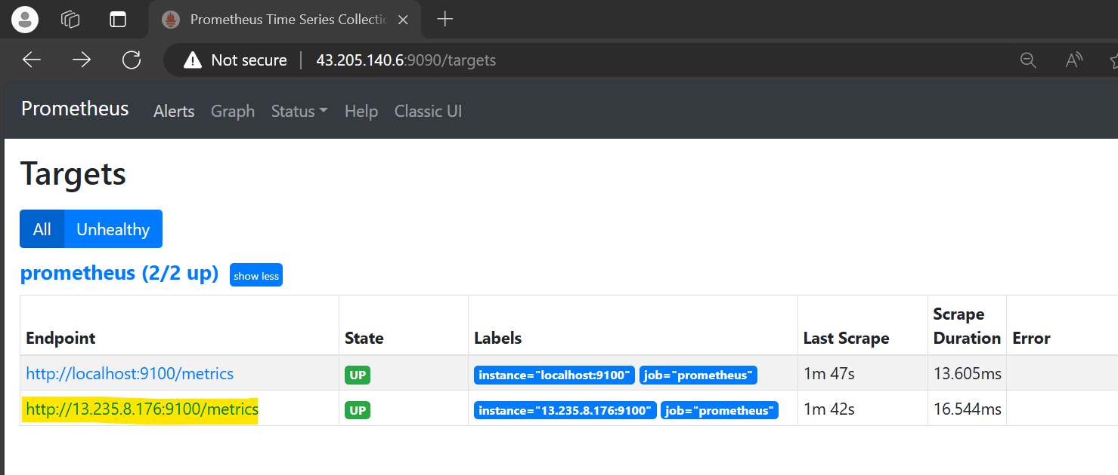

Now in Grafana, you can able to view the metrics in the below screen-print

